Chapter 14, Problem 61.

Find the transfer function for each of the active filters in Fig. 14.90.

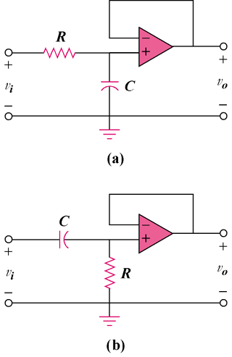

Figure 14.90
For Prob. 14.61.

